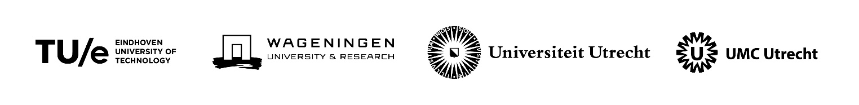
Seed Fund alliance TU/e, WUR, UU, UMC Utrecht (EWUU)
Call March 2022, deadline March 1st

<Maximum 3 pages with Verdana 9 and a maximum of 1900 words>

- Applicant information

< Please fill in on the first row the name of the main applicant>

Name | Institution | Department | Position | Email

- Title and summary
  - Title:
  - Brief summary of proposed project:
  - What result will the project have as deliverable (application for external funds, event etc):
  - Budget required:
  - Start and end date of the project:
  - Societal partners involved:

Contribution to the strategy of the alliance
- Elaborate on the innovative aspects of the project and the proposed interdisciplinary aspects of the proposal.
- Indicate to what extent the applicants have worked together before.
- Describe the (potential) contribution of the project to the goals of the alliance and the societal and/or scientific contribution.
- Indicate how young scientist or students are involved.
- For applications aimed at societal added value, describe which societal partners are involved or will be involved.
- For applications aimed at preparing a grant application, describe how the investments contribute to increasing the chances of success of the grant application.

Workplan and Deliverable(s)
Describe briefly the workplan and time schedule, and the expected deliverable(s).

Budget
- Explain the use of the funds in relation to the workplan and deliverable(s).
- Indicate whether you are applying for other funds for this proposal.

Support deans/managing directors/chair of strategic theme

Please indicate which deans (TUe and UU)/managing directors (WUR)/chair of strategic theme (UMC Utrecht) support the proposal.

Brief cv applicants
Please include a brief CV of the applicants (± 50-60 words per applicant).

Proposals should to be sent to e.i.stiekema@uu.nl with a deadline of March 1st 2022.

