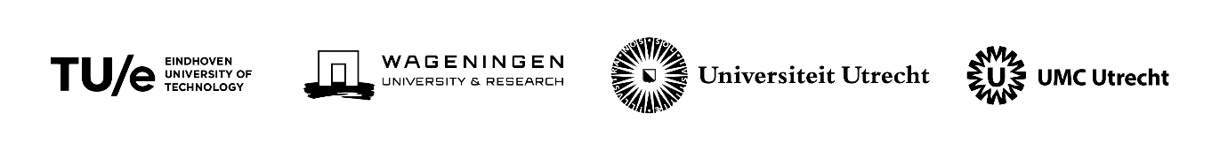

Criteria for the Seed Fund Alliance TU/e, WUR, UU, UMC Utrecht (EWUU)
Deadline 1 March 2023

Eindhoven University of Technology, Wageningen University & Research, Utrecht University and Utrecht University Medical Centre entered into a strategic alliance in 2019 with the aim of working intensively together on a number of themes where the partners are complementary and can strengthen each other: Health, Food, Energy and Circular Society.

The alliance wants to offer staff members the opportunity to explore new interdisciplinary connections between the partner institutions. We have set up a Seed Fund for small-scale initiatives such as preparing an external grant application, developing a new course, organizing an event or setting up collaboration with social partners.

In 2023 there will be two opportunities to apply for seed money. Deadlines are 1 March and 1 July. In each call, funds are available to award three to four proposals.
The deadline for the next round is 1 March 2023.

This call provides information on the eligibility criteria that all applications must meet and on the quality criteria on which the applications will be judged. It also provides information on how applications can be submitted.

Criteria

Eligibility criteria
Applications must meet a number of eligibility requirements. Applications that do not meet these requirements will be disqualified and will not be reviewed by the Seed Fund Committee.

- At least 3 of the 4 partners within the alliance are involved in the proposal.
- The application should focus on (one of) the alliance's themes: Health, Food, Energy and Circular Society, but may include all academic disciplines.
- The application amounts to a minimum of 10 k€ and a maximum of 50 k€.
- The maximum duration of the project is 1 year.
- Applications may not be longer than 3 pages and 1900 words. Applicants must use the template provided on the website.
- The application must be supported by the relevant members of the General Assembly. In TU/e and UU this is the dean of the faculty, in the WUR this is the managing director, in the UMC Utrecht the chair of the strategic theme.

Quality criteria
The Seed Fund Committee will assess the application on the following criteria:

- Innovative content of the collaboration. The proposal itself is innovative and combines disciplines in a new way.
- New collaboration. The collaboration is between participants who have not worked together before.
- Young talent. The proposal involves or is aimed at students and/or young researchers.
- The application contributes to achieving the objectives of the alliance and is aimed at realizing societal and/or scientific added value. For applications aimed at societal added value, the involvement of social partners is relevant.
- Feasibility and proportionality. The objectives achievable and realistic and the budget is in balance with the intended result of the application.

How to apply

- Applicants should use the template, with a maximum of 3 pages and 1900 words.
- The application should indicate:
  - Who the applicants are, including a very short CV;
  - Which innovative combination of disciplines is envisaged;
  - To what extent the applicants have worked together before;
  - What results are envisaged and when they can be expected;
  - How the resources will be used to achieve the results, including budget;
  - When the project is completed.
- Applications can be submitted to the following email address: e.i.stiekema@uu.nl with a deadline of 1 March 2023.

The template is available on the website https://ewuu.nl/en/collaboration/seed-fund/

End of the project
Successful projects must submit a report at the end of the project with a brief financial account and a summary of the deliverables.

Selection and allocation procedure
Applications that do not meet the eligibility criteria will not be considered by the Seed Fund Committee.
Applications that do meet the eligibility criteria will be assessed by the Seed Fund Committee on the basis of the quality criteria mentioned above. Applications will be ranked on quality and awarded in order. In each call three proposals will be awarded.

