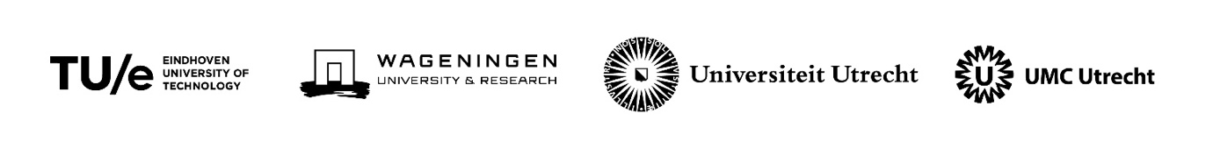

Application Form Educational Research Projects
Alliance TU/e, WUR, UU, UMC Utrecht (EWUU)
Educational Research in Educational Innovations to Stimulate Adaptive Performance
Deadline April 1, 2023. Send the proposal to Antoine van den Beemt, edures.ewuu@tue.nl

Project title
Main applicant (contact person):
full name, position, url of profile, email-addresses, affiliation, role in the research team.
Co-applicant(s):
full names, position, url of profile, email-addresses, affiliation, role in the research team.
Summary of the project (max. 200 wrd)
Scientific and practical relevance Explain the contribution to the educational research goals of alliance (max. 300 wrd)
Theoretical background and methodological description of the project (max. 500 wrd)
Dissemination (max. 100 wrd)
Team How do the applicants as a team complement each other in expertise and connect to alliance partners? (max. 200 wrd)

Workplan
Describe the planning of the project, related to the budget template file (max 200 wrd)

